

Best Share Market Classes in Pune
If you are searching for Share Market Classes in Pune to learn the stock market through structured and practical training, Chaitanya Share Market Classes provides a complete learning environment for beginners, investors and aspiring traders.
Established in 2008, Chaitanya Share Market Classes focuses on helping students understand how the Indian stock market works through practical examples, market analysis and disciplined learning. Students learn concepts ranging from stock market basics to Technical Analysis, Intraday Trading, Swing Trading, Futures Market & Options Market, All Option Trading Strategies, Risk Management, Money Management and Portfolio Management.
Our objective is not to encourage students to depend on tips or predictions. We focus on developing the knowledge and analytical skills required to understand the market and make independent trading and investment decisions.



Why Choose Chaitanya Share Market Classes in Pune?
Choosing the right share market course in Pune is important because stock market learning requires more than theoretical information. Students need structured education, practical examples and an understanding of how concepts are applied in actual market conditions.
At Chaitanya Share Market Classes, the learning process is designed to take students step by step from basic concepts to advanced market analysis.
Key Highlights
✔ Share Market Training Since 2008
✔ 17+ Years of Teaching Experience
✔ 20,000+ Students Trained
✔ 3,000+ Google Reviews
✔ Practical Market-Oriented Training
✔ Technical Analysis Training
✔ Intraday Trading Concepts
✔ Futures & Options Training
✔ Swing Trading Strategies
✔ Risk & Money Management
✔ Recorded Learning Support
✔ Lifetime Learning Support

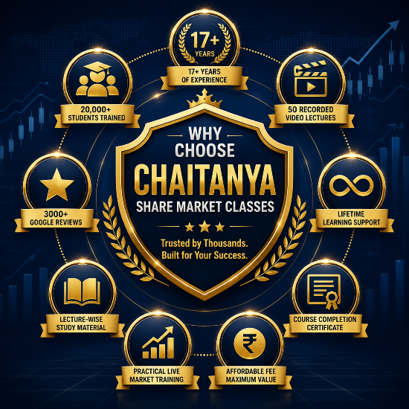

What Will You Learn in Our Share Market Course?

A complete Share Market Course in Pune should help students understand different areas of the financial markets rather than focusing on only one trading technique.
At Chaitanya Share Market Classes, students learn:
Share Market Basics
Understand stock exchanges, indices, market participants, order types and the basic functioning of the Indian stock market.
Technical Analysis
Learn chart reading, trends, support and resistance, indicators, price behavior and other concepts used for analysing market movements.
Intraday Trading
Understand the concepts involved in analysing and planning trades within the same trading session, including entry, exit and risk management.
Swing Trading
Learn how traders analyse short- to medium-term market movements and identify potential trading opportunities using technical analysis.
Futures & Options
Understand derivatives, futures contracts, call and put options, option concepts and different approaches to analysing F&O markets.
Risk & Money Management
Learn position sizing, stop-loss concepts, capital protection and disciplined approaches to managing trading risk.

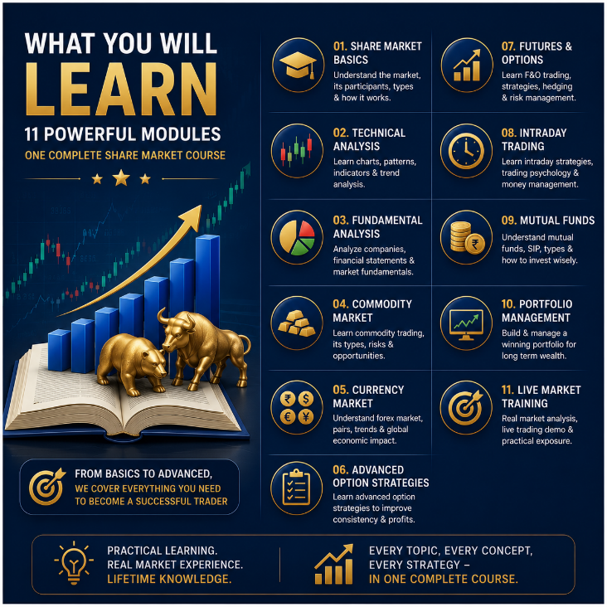

Who Should Join Our Share Market Classes in Pune?
Our Share Market Classes in Pune are designed for anyone who wants to understand the stock market through structured and practical learning. No previous trading experience or commerce background is necessary to start learning.
The course is suitable for:
✔ Beginners who want to learn the stock market from the basics.
✔ Students interested in investing, trading and financial markets.
✔ Working professionals looking to improve their financial knowledge.
✔ Business owners who want to understand investment opportunities.
✔ Homemakers interested in learning stock market investing and trading.
✔ Retired individuals who want to understand investment decisions better.
✔ Existing investors who want to improve their market analysis skills.
✔ Traders interested in Technical Analysis and chart reading.
✔ Learners interested in Intraday Trading and Swing Trading.
✔ Students who want to understand Futures and Options systematically.
The learning process begins with fundamental market concepts and gradually progresses toward advanced trading and analysis techniques.



Practical Share Market Training with Real Market Examples

Understanding concepts is important, but knowing how those concepts relate to actual market situations makes learning more meaningful.
Our Share Market Course in Pune focuses on practical learning through market examples, chart analysis and application-oriented explanations. Students learn how market trends develop, how charts are analysed and how risk should be considered before making a trading or investment decision.
Practical learning helps bridge the gap between theoretical knowledge and real-world market understanding. The objective is to develop independent thinking rather than dependence on stock tips, rumours or social-media recommendations.



Offline & Online Share Market Classes

Every learner has a different schedule and preferred way of learning. Therefore, Chaitanya Share Market Classes provides both Offline Share Market Classes in Pune and online learning options.
Students attending offline classes get the benefit of direct classroom interaction and practical explanations, while online learning provides flexibility for students who cannot attend regular classroom sessions.
Both learning options are designed around the same objective — making complex stock market concepts easier to understand through structured and practical education.

Frequently Asked Questions About Share Market Classes in Pune

H3: 1. Which are the best Share Market Classes in Pune?
The right share market class should provide structured learning, practical training, risk management education and continued learning support. Chaitanya Share Market Classes has been providing share market education in Pune since 2008, covering topics from stock market basics to Technical Analysis, Intraday Trading, Futures & Options and Swing Trading.

H3: 2. Can beginners join Chaitanya Share Market Classes?
Yes. The course is designed to start from basic stock market concepts, so beginners can join even without previous trading or investing experience.

H3: 3. What topics are covered in the Share Market Course?
The course covers Share Market Basics, Advanced Concepts, Technical Analysis, Fundamental Analysis, Intraday Trading, Swing Trading, Futures, Options, Commodity, Currency, Risk Management, Money Management and Portfolio Management.

H3: 4. Do you provide Technical Analysis training?
Yes. Technical Analysis is an important part of the course. Students learn concepts related to charts, trends, support and resistance, candlesticks, indicators, volume, entry and exit planning and risk management.

H3: 5. Do you provide Intraday Trading Classes in Pune?
Yes. Intraday Trading concepts are included in the training. Students learn market analysis, trade planning, entry and exit concepts, stop-loss planning, risk management and trading discipline.
Internal Link: Intraday Trading Classes in Pune →

H3: 6. Do you teach Options Trading?
Yes. Students are introduced to Futures & Options, including Call and Put Options, Strike Price, Premium, Expiry, Option Buying and Selling concepts and different Option Strategies.
Internal Link: Option Trading Classes in Pune →

H3: 7. Is Swing Trading included in the course?
Yes. Students learn how Technical Analysis, market trends, support and resistance and price behaviour can be used while studying Swing Trading opportunities.
Internal Link: Swing Trading Course in Pune →

H3: 8. Are Offline Share Market Classes available in Pune?
Yes. Students can attend offline classroom training in Pune. Online learning options are also available for students who prefer flexible learning.

H3: 9. Will I receive recorded lectures?
Yes. Students receive access to 50 recorded lectures that can be used for revision and continued learning.

H3: 10. Do students receive a certificate after completing the course?
Yes. Students receive a Course Completion Certificate after successfully completing the training program.

Note :- Add read more tab after three Question

Start Your Share Market Learning Journey

If you are looking for professional Share Market Classes in Pune and want to learn the market through structured, practical and disciplined education, Chaitanya Share Market Classes can help you begin your learning journey.
Whether your interest is in Technical Analysis, Intraday Trading, Option Trading, Swing Trading or long-term investing, our training is designed to help you understand market concepts and develop independent analytical skills.

Ready to Learn the Share Market?
Limited Seats Available for Upcoming Batch
CALL NOW | WHATSAPP NOW | BOOK YOUR SEAT



Meet Your Mentor

Learn from an Experienced Mentor Who Has Been Teaching the Stock Market Since 2008.

The right mentor can make the difference between confusion and confidence.
For more than 17 years, Kishor Bhandage has been helping thousands of students understand the stock market through a practical, easy-to-understand and result-oriented teaching approach.
Instead of focusing on shortcuts or tips, his training is designed to help students build strong market knowledge, develop analytical thinking and gain the confidence to make independent investment and trading decisions.
Over the years, 20,000+ students from different backgrounds—including beginners, professionals, business owners, homemakers and retired individuals—have successfully completed the training.
His teaching combines real market experience, practical examples, live chart analysis and structured learning, making complex market concepts simple for every student.
The mission has always remained the same:
To help every student become a confident investor and trader through quality education, practical learning and continuous support.



Our Commitment to Every Student
At Chaitanya Share Market Classes, our commitment goes beyond classroom training.
We believe that every student deserves practical knowledge, continuous guidance and the confidence to participate in the stock market independently.
Our promise is simple:
We don't just teach the stock market—we help you build a lifelong financial skill.
From your first lecture to your continued learning after course completion, we remain committed to supporting your journey.

What You Get After Completing the Course

🎓 Course Completion Certificate

🎥 50 Recorded Video Lectures

♾️ Lifetime Learning Support

📚 Study Material

📱 Free Demat Account Assistance

खाली

Benefits of Learning Share Market
Cards मध्ये:
💰 Build a Second Source of Income
📈 Long-Term Wealth Creation
🧠 Improve Financial Decision Making
🚀 Career Opportunities in Financial Markets
💼 Start Your Own Trading & Investment Journey



Our Unique Learning Methodology

Designed to Help You Learn, Practice and Succeed.

Learning the stock market is not about memorising concepts—it's about understanding how markets work and applying that knowledge confidently.
At Chaitanya Share Market Classes, our teaching methodology combines structured classroom learning with practical market exposure, helping students build strong concepts from the basics to advanced trading techniques.
Every session is designed to make learning simple, interactive and easy to understand for beginners as well as experienced learners.

खाली 4 Premium Cards

📘 Learn
Build strong fundamentals through structured classroom sessions.

📊 Practice
Understand real charts and live market movements.

🧠 Analyses
Develop independent decision-making and analytical skills.

🚀 Apply
Use your knowledge confidently in real market situations.

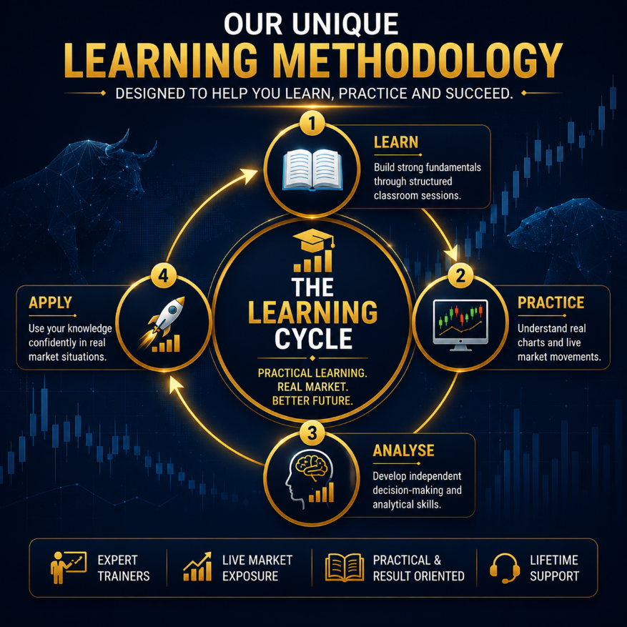

Trusted by 20,000+ Students Across India
More than 3,000+ Google 5-Star Reviews Reflect Our Commitment to Quality Education.

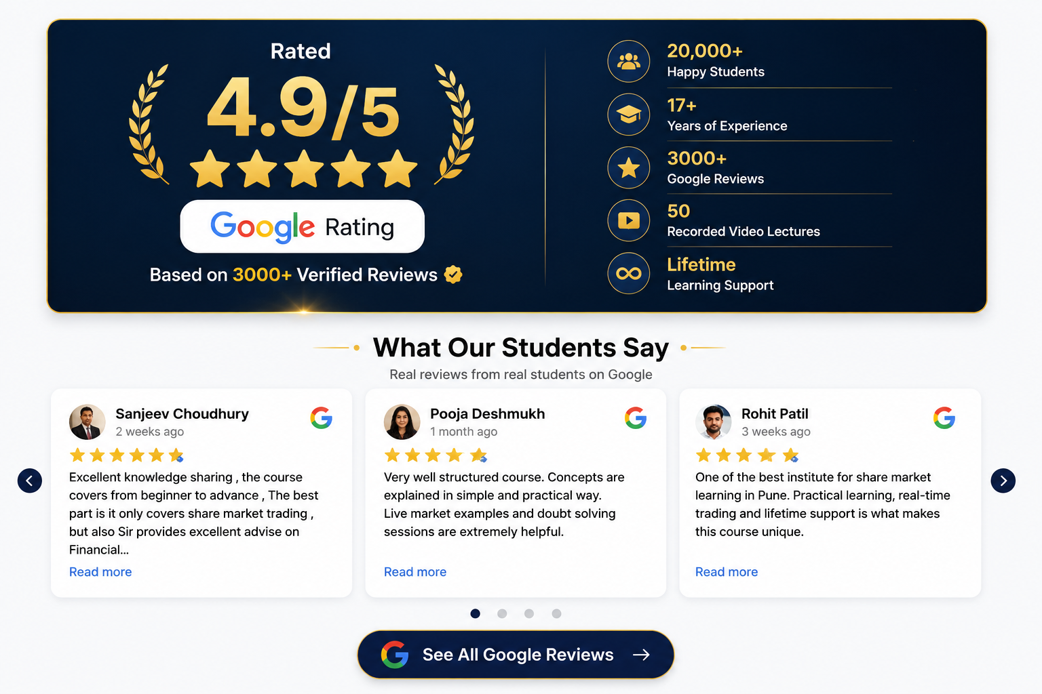

See Why Thousands of Students Recommend Chaitanya Share Market Classes
View More Google Reviews

Chaitanya in Numbers

17 Years of Trust. Thousands of Success Stories.

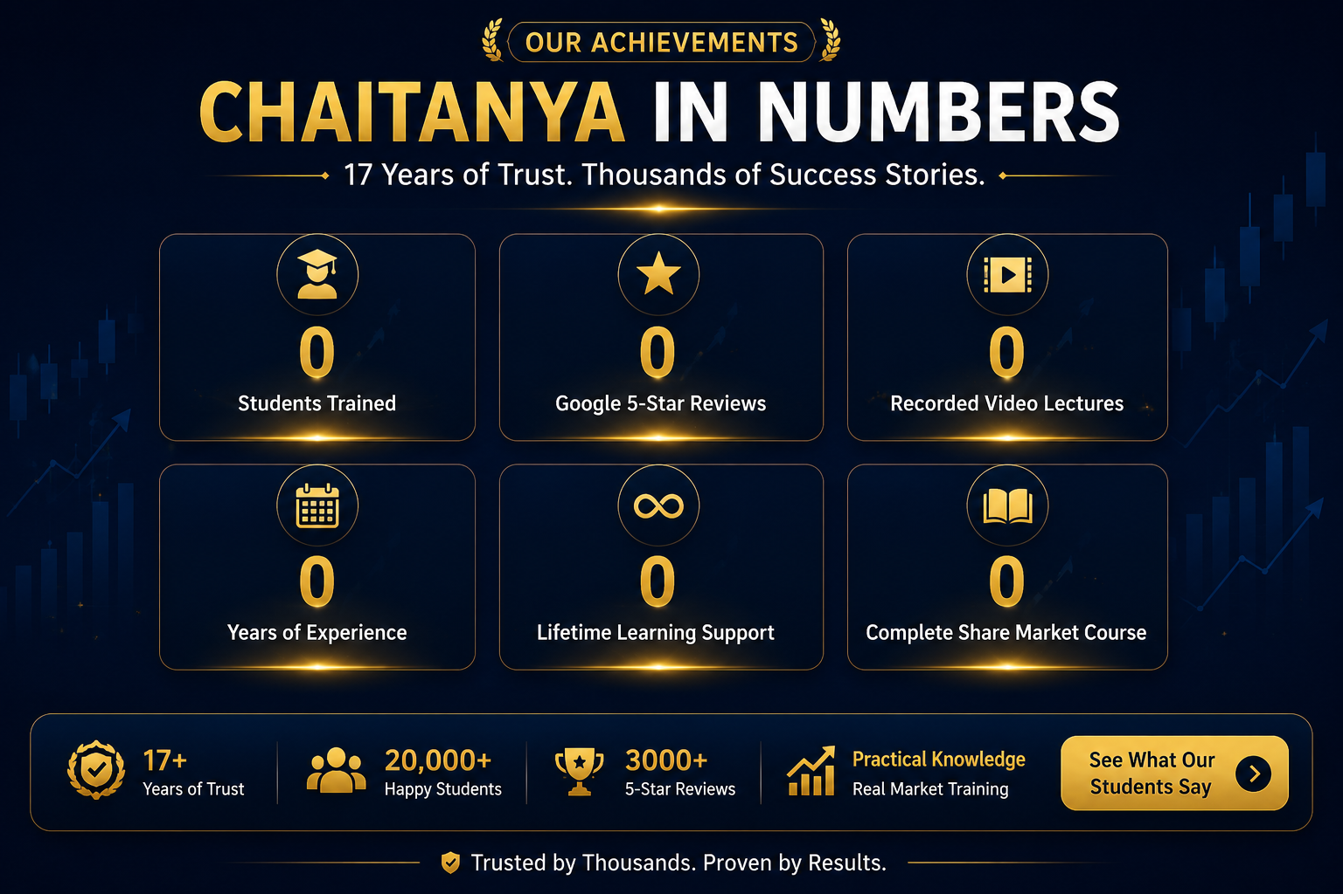

Student Trained 20000+
Google 5 Start Reviews 3000+
Recorded video lecture 50+
Year of Experience 18+
Course fee 6000
Module Cover in One Course 9+



